TASK 8: Jenkins Installation and Continuous Integration (CI) Job
Project: Dockerized Book Issue and Return System
Name: Swar Sawalkar
Roll No.: 23104B0023
Department: CMPN, Fourth Year
Division: C

1. Aim
To install and configure Jenkins for the Dockerized Book Issue and Return System and create a Continuous Integration (CI) job that automatically retrieves source code from GitHub, builds the application using Maven, executes unit tests, and reports the build status.
2. Objectives
- Install and configure Jenkins.
- Integrate Jenkins with the GitHub repository.
- Configure a Maven build job.
- Automate compilation and unit testing.
- Verify the build console output and test results.
- Understand the role of CI in DevOps.
3. Theory
Jenkins is an open-source automation server used to implement Continuous Integration and Continuous Delivery (CI/CD). Continuous Integration involves frequently integrating code changes into a shared repository and automatically building and testing the application.
In this project, Jenkins retrieves the source code of the Book Issue and Return System from GitHub. Maven compiles the Spring Boot application and executes its tests. If the build or tests fail, Jenkins reports a failed build so that developers can identify and fix the issue early.
4. Procedure
Step 1: Install and start Jenkins
Jenkins can be installed on a local computer or a suitable server/virtual machine. For a local Windows installation:
- Install a compatible Java version required by the selected Jenkins release.
- Download the Jenkins Long-Term Support (LTS) installer from the official website.
- Run the installer and configure the Jenkins service.
- Open Jenkins in a browser, usually at http://localhost:8080.
- Unlock Jenkins using the initial administrator password.
- Install the suggested plugins and create an administrator account.
Official download: Jenkins Downloads
Step 2: Configure the Jenkins environment
Ensure the Jenkins build environment has the required tools:
- JDK compatible with the project.
- Apache Maven.
- Git.
For this Spring Boot project, Maven is used to build and test the application.
If Jenkins runs as a service, verify that the service account can access the required tools and project workspace.
Step 3: Create a Jenkins job
- Open the Jenkins dashboard.
- Click New Item.
- Enter the job name Book-Issue-Return-CI.
- Select Freestyle project.
- Click OK.
Step 4: Connect the GitHub repository
In the job configuration:
- Locate Source Code Management.
- Select Git.
- Enter the repository URL:
https://github.com/swar071005/Devops_Project.git
- Configure the branch to build, for example */develop.
- If the repository is private, configure valid Git credentials in Jenkins.
For a public repository, authentication may not be required for cloning.
Step 5: Configure the build steps
Under Build Steps, select Execute shell on Linux-based Jenkins or Execute Windows batch command on Windows.
For a Linux-based Jenkins agent with Maven installed, enter:
mvn clean test
This command cleans previous build output, compiles the project, and executes the configured tests.
If Maven is not available on the Jenkins agent, configure it in Manage Jenkins → Tools or install it in the agent environment first.
Step 6: Configure build triggers
Under Build Triggers, select an appropriate option:
- Poll SCM to periodically check for source changes.
- GitHub hook trigger for GITScm polling if a GitHub webhook is configured correctly.
For an initial demonstration, you can leave automatic triggers disabled and run the job manually using Build Now.
Step 7: Run the CI job
- Save the job configuration.
- Open the Book-Issue-Return-CI job.
- Click Build Now.
- Open the latest build number.
- Click Console Output.
- Review the Maven build and test logs.
A successful build normally ends with BUILD SUCCESS. If the database or another dependency is unavailable, the tests may fail and Jenkins should report that failure rather than a successful CI run.
5. CI Workflow Diagram
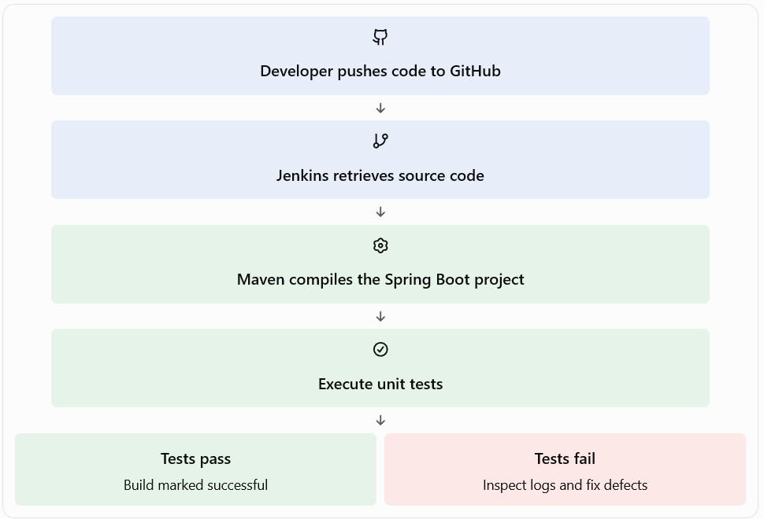

6. Screenshots to include in the report
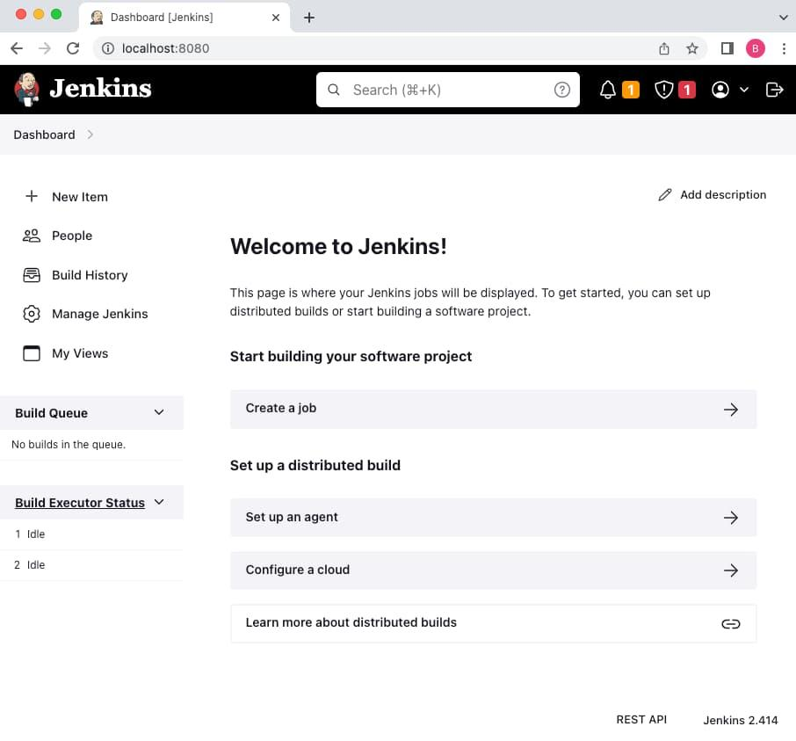

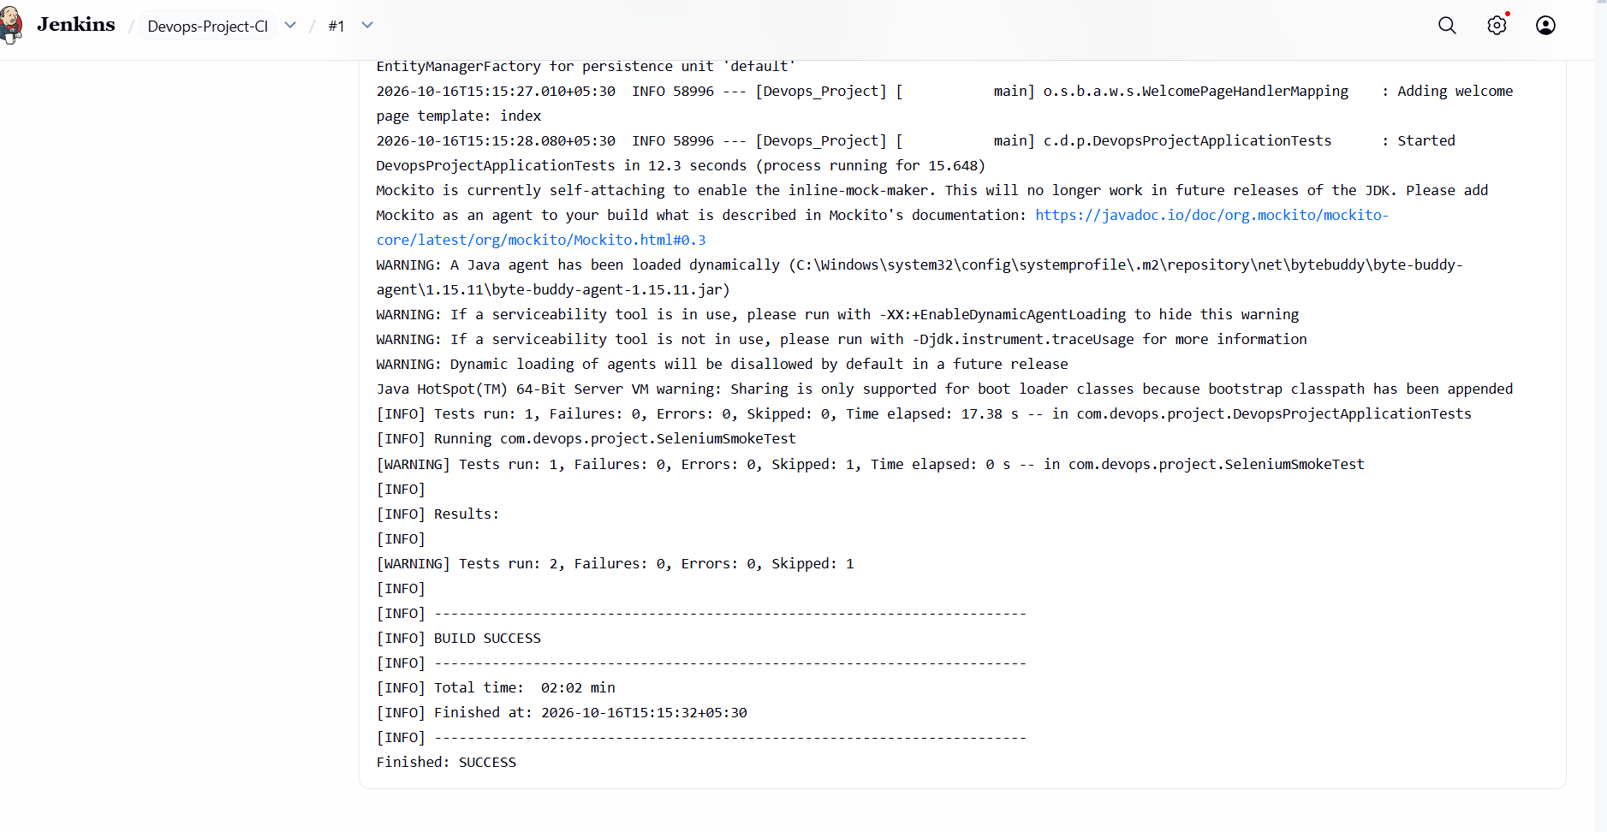
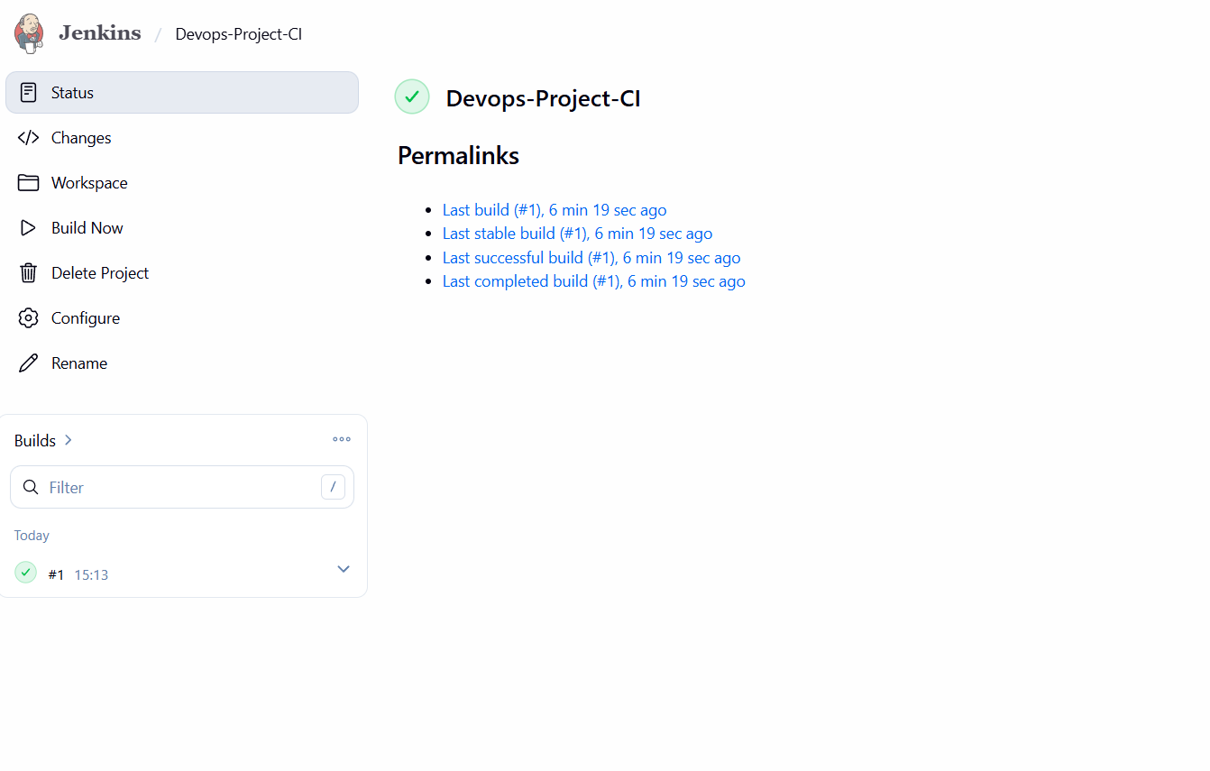
9. Conclusion
Jenkins automates the build and testing stages of the DevOps workflow. Integrating Jenkins with GitHub helps detect coding and testing errors early, improves software quality, and provides a foundation for the later deployment pipeline.

